**Circuit Breaker using Resilience4j**

Netflix Eureka,Resilience 4j are the two tools commonly used in circuit breaker

**Resilience 4j features & modules:**

1.Circuit Breaker(fault Tolerance)

2.Rate Limiter(block too frequent requests)

3.Time Limiter(set a time limit when calling remote operation)

4,Retry Mechanism(Automatically retry a failed remote operation)

5. Bulkhead(Avoid too many concurrent requests)

6. cache(store results of costly remote operations)

**Webclient:**

**How to Add webclient in the service**

RestTemplate uses Java Servlet API and is therefore synchronous and blocking. Conversely, WebClient is asynchronous and will not block the executing thread while waiting for the response to come back. The notification will be produced only when the response is ready.0

**Add Spring WebFlux Dependency in vaccination-service**

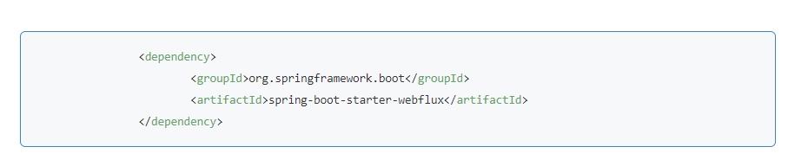

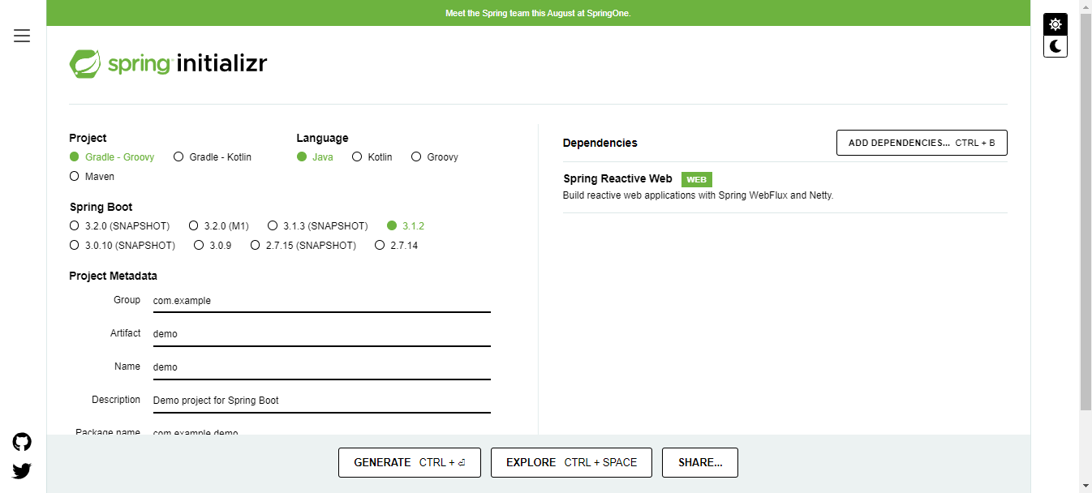

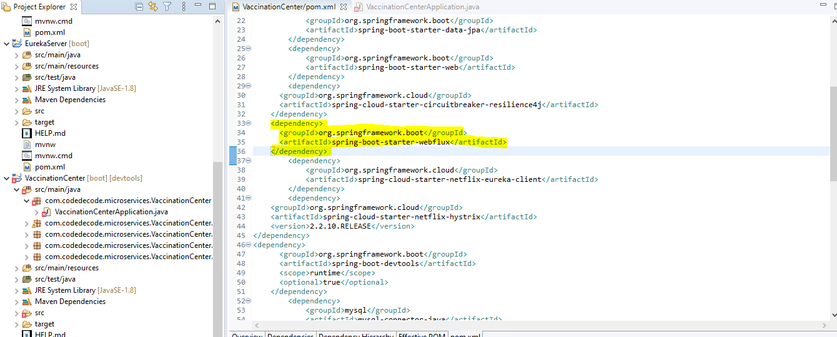

**2.Then need to add the Webclient in my Application**

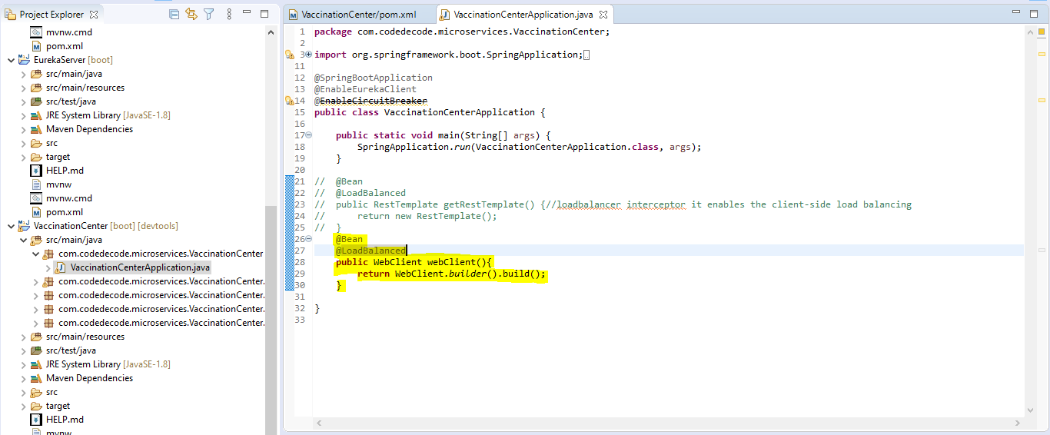

# 3. Inject and Use WebClient to Call the REST API

**FeignClient:**

why we are moving to feign client instead of RestTemplate and webclient?

The Feign client is a declarative REST client that makes writing web clients easier. When using Feign, the developer has only to define the interfaces and annotate them accordingly. The actual web client implementation is then provided by Spring at runtime

**difference between feign client and RestTemplate**

One of the advantages of using Feign over RestTemplate is that, we do not need to write any implementation to call the other services. So there is no need to write any unit test as there is no code to test in the first place. However, it is advised that we write Integration tests

**difference between feign client and WebClient**

FeignClient also allows you to easily switch between different HTTP transport libraries, like OkHttp or Apache HTTP Client. It is built on top of the Retrofit library. WebClient, on the other hand, is a non-blocking, reactive client for making HTTP requests.

How to step up feign Client in application ?

1.Add Spring cloud open feign Maven dependency to Vaccination-Service

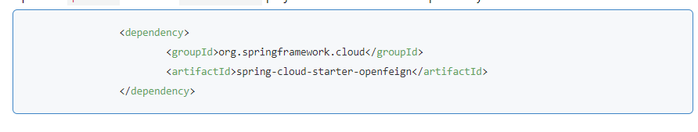

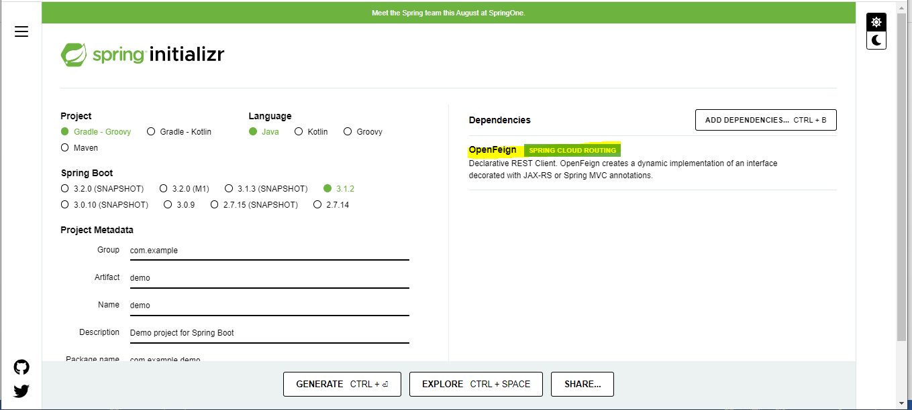

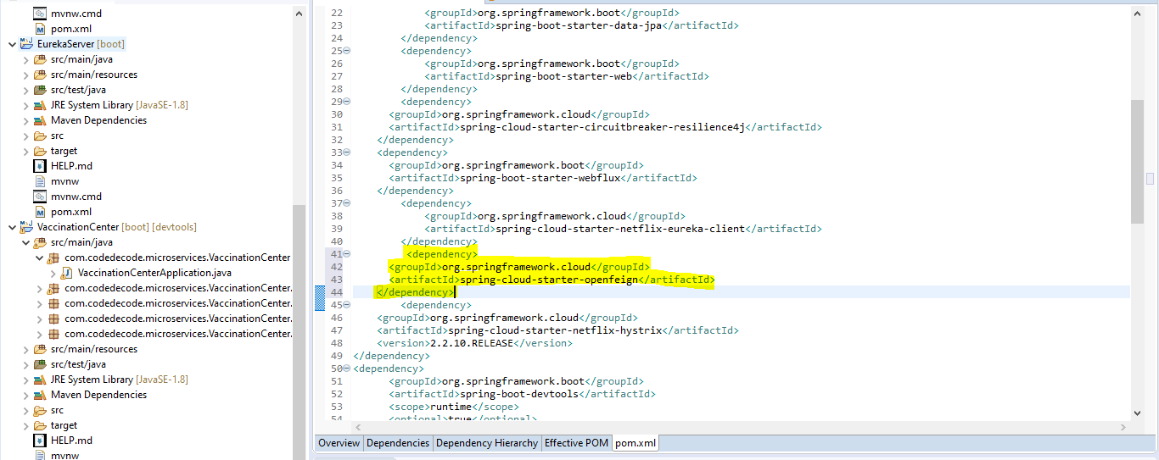

# 2. Enable Feign Client using @EnableFeignClients

# 

# 3. Create feign API client

**How to work with Resilience4j in Circuit breaker ?**

**Steps for Resilience4j:**

First need to add the Resilience4j dependency in the pom.xml of the spring boot application

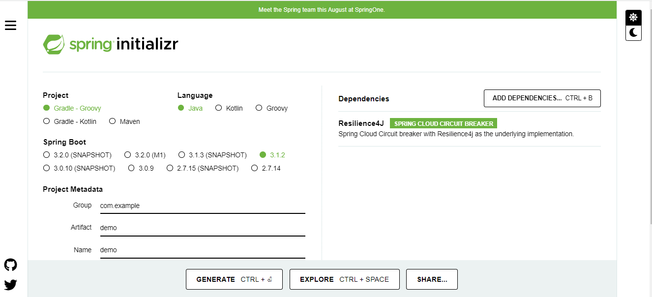

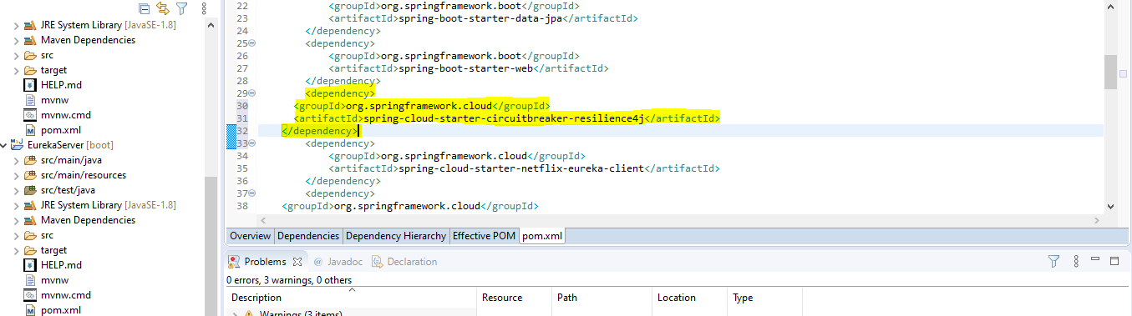

2.Then need to add @Enable CircuitBreaker in the method and add the fallback method name

